# Kiwi Budget : A Database of New Zealand Economic Activities (1996 ~ 2022)

Authors : Ali Ansar, JinZe (Jerry) Zhou, Mingqiu(Jeffrey) Chi

## Abstract

This database contains information from various major social economical activities of New Zealand as well as its key monetary policy indicators. All data are time series based, they have been collected from websites like “interest.co.nz”, “interest.co.nz”, “interest.co.nz” and so on. The reuse potential includes finance department of New Zelanad companies for training machine learning algorithms that does the forecasting as well as visulisation. This database is available through xxx??

**KeyWords :** Monetary policy, Economic activities,

## Overview

Repository location

[https://github/kiwi-economy/1996-2022](https://kiwi-economy/1996-2022)

### Context

New Zealand is a relatively small economical entity that is heavily relying on overseas business, such as Tourism coming into the country and export our diary products. Facing an increasing turbulent international political and economical environment (Russia and Ukraine war, Trade war between China and U.S. and covid-19 Pandemic), in order to maintain our prosperity, in depth analysis on how does New Zealand vital economical policy impact on our main economical activities are not only useful but also crucial for the success of New Zealand companies. Especially companies like Air NewZealand, Kiwi Rail and Tourism New Zealand.

Monetary policy that are measures employed by governments to influence economic activity, specifically by manipulating the supplies of money and credit and by altering rates of interest. The usual goals of monetary policy are to maintain full employment, to achieve high rate of economic growth, and to stabilize prices and wages. High CPI trends in the recent years, however, caused New Zealand governments to adopt measures that either stimulate the growth of the economy or reduced inflation by restricting growth in the money supply.

### Purpose :

Our goal of this project is to create a data model that is able to explain the insight of the main economic activities. We are aiming at collecting economic data such as monetary policy indicators, house price indices, tourism data and import/export data, with the expectation of seeing correlations between the data and providing a perspective on the New Zealand economy. The data will also provide a data base for further research to follow.

## Methods

### Step2

### 1: Sourcing, Tidying and Enhancing New Zealand Economy Dataset

### A: What data sources you used :

From <https://infoshare.stats.govt.nz.> we have managed to obtain the following data sources

1. Work income and spending
2. Household labour force survey - HLF
3. Labour force status for people aged 15 to 64 years : Seasonally adjusted

We have scraped data source such as 1) Historical CPI data, 2) Historical New Zealand Exchange Rate data, 3) Historical New Zealand Cargo Freight Transportation data, 4) Historical New Zealand Air Freight Data, 5) Historical New Zealand Tourism Count

1.What data model is in our minds for which we collected our datasets?

We intended to create a relational database that store both the New Zealand monetary policy data as well as NZ’s economical activities data.

2. Who is or can use our data model?

The intended users of our data sources are Like Air New Zealand CEO, KiwiRail CFO, Tourism New Zealand CFO and Reserve Bank policy maker, Ministers etc, who will be interested in finding how do our economical policy impact New Zealand main economy.

We use “Julia” to collect “Official Cash Rate”, “CPI”, “HPI” and “NZ-USD Exchange Rate” data from “interest.co.nz” and “www.ofx.com” for

### B : Why you choose those data sources

We choose Infoshare for our datasource, because “infoshare” is a free service provided by Statistics New Zealand to allow viewing survey data. The offical background of the datasource give it high crediability.

### E : What techniques you did see

For data scraping, various techniques have been utilized for direct data file downing, web scraping,

We have installed following packages ("RSelenium", "Writexl" and "here" packages) utilized following libraries

1. magrittr The magrittr (to be pronounced with a sophisticated french accent) package has two aims: decrease development time and improve readability and maintainability of code. Or even shortr: make your code smokin’ (puff puff)!
2. polite Be responsible when scraping data from websites by following polite principles: introduce yourself, ask for permission, take slowly and never ask twice.
3. rvest Wrappers around the 'xml2' and 'httr' pa ckages to make it easy to download, then manipulate, HTML and XML
4. here The goal of the here package is to enable easy file referencing in project-oriented workflows. In contrast to using setwd(), which is fragile and dependent on the way you organize your files, here uses the top-level directory of a project to easily build paths to files.
5. RSelenium Provides a set of R bindings for the 'Selenium 2.0 WebDriver' (see https://www.selenium.dev/documentation/ for more information) using the 'JsonWireProtocol' (see https://github.com/SeleniumHQ/selenium/wiki/JsonWireProtocol for more information). 'Selenium 2.0 WebDriver' allows driving a web browser natively as a user would either locally or on a remote machine using the Selenium server it marks a leap forward in terms of web browser automation. Selenium automates web browsers (commonly referred to as browsers). Using RSelenium you can automate browsers locally or remotely.

### 2: Creating the Historical Monetary Policy & Economic Activities Dataset

### F : What you managed to achieve and what you failed to do

Our team decided to collect data that relates various social & economical activities in New Zealand; we will attempt to collect monetary policies data such as CPI, HPI, Exchange Rate as well as Inflation. Other economical activities data such as but not limited to “Transportation data”, “Ferry data”, “Tourism Satellite Account”.

The aforementioned data could come from different types of sources, we have observed data source type like “html”, “pdf”, “csv”, “excel file” and “Rest api”.

We plan to retrieve aforementioned data via these different sources first, then through the process of data wrangling to transform these data sources into relational database;

The final deliverable of our project should be a relationship database, that contains all aspects of New Zealand economic activities as well as government monetary policies. Such database can be utilized for further data mining analysis as well as data visualization tasks. We will plot a simple flow chart diagram to indicates the correlation between some of the chosen data, for example “Exchange Rate” VS. “Tourism Satellite Account”. It is anticipated that as exchange rate drops, New Zealand dollar becomes cheaper, we should be able to observe an increase of “Tourism account”.

## Database description



## Reuse potential

### The final output database can be potential reused for visualizations that can reveal the relationship between various kinds of economic activities VS. Monetary policies indicators.

## Additional files

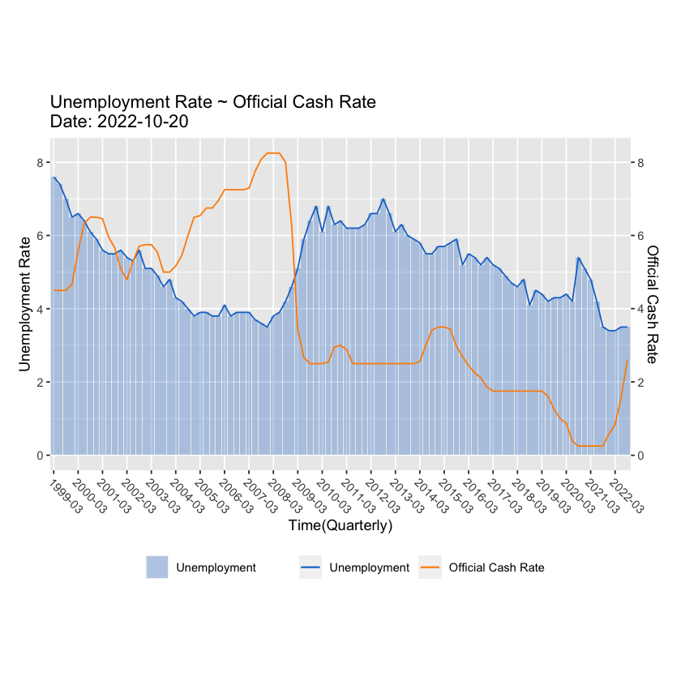

The above chart reveals the relationship between “Unemployment rate” VS. “Official Cash Rate”; Higher OCR leads to Higher interest rates could lead to rise in unemployment. In the above graph we produce, for the majority of the timeline, the positive correlation between “Unemployment rate”and “OCR” has been observed, which complies to the economic theory. There are exceptions like between year 2003 to year 2008, consider New Zealand economy is heavily rely on export, other factors such as “NZ dollar VS. US dollar exchange rate” which influence the export business would be used to explain this phenomenon.

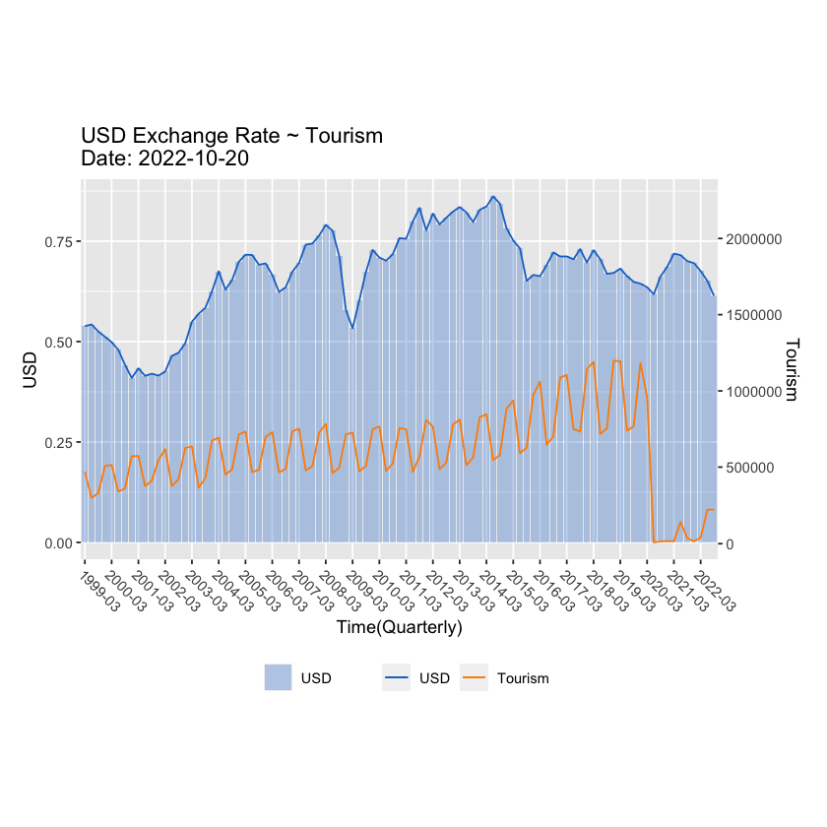

We have plotted “”

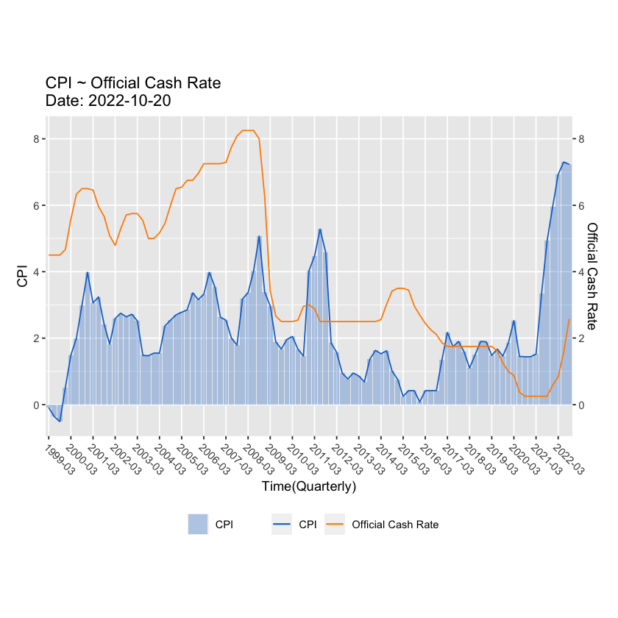

The official cash rate (OCR) is the interest rate set by the Monetary Policy Committee (MPC). It affects the price of borrowing and saving.

What is the relationship between inflation rate and interest rate?

The relationship mirrors basic supply and demand principles.

As inflation falls, so do interest rates. It becomes less expensive to borrow money,

thus there's more money circulating in the economy. Since supply remains relatively constant,

demand for goods and services increases—thus increasing prices and inflation.

Such positive correlation between “OCR” and “CPI” has been observed from above plot.

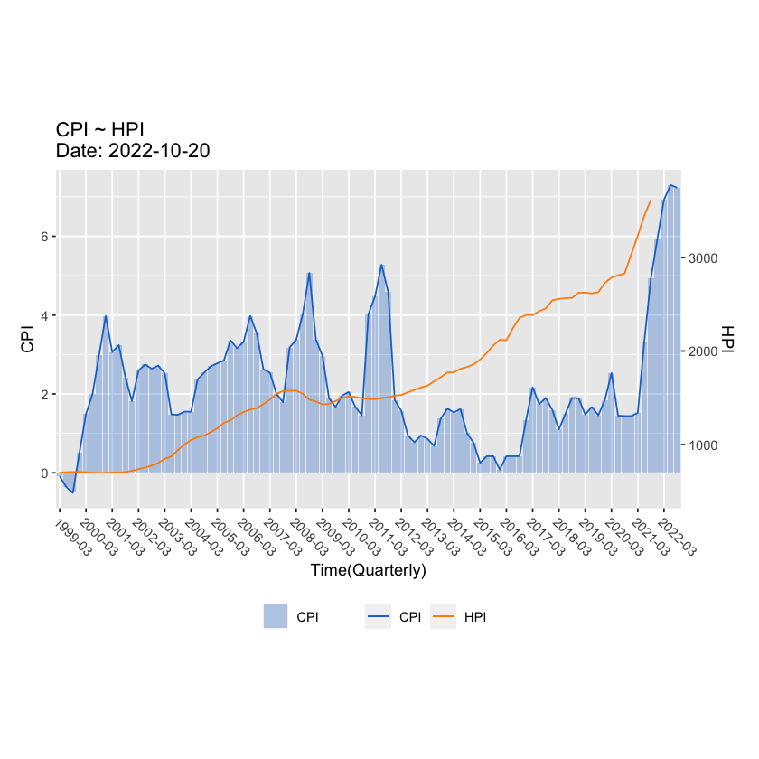

From above plot, we can see that the growth of the HPI starts to exceed the growth of the CPI from year 2012 onwards, from this diagram, we can appreciate the occurrence of the housing affordability issues. CPI usually relate to affordability of food, drink and other commodities. From reading this chart, we can see from year 2017, both CPI and HPI are surging, indicates affordability issues of both the commodities and housing. Under such circumstances Government should step to ease the surging of the inflation in short term by raise interest rate, but in long term, the solution lies in building more houses and increase our productivity as well as finding cheaper source of purchasing affordable commodities.

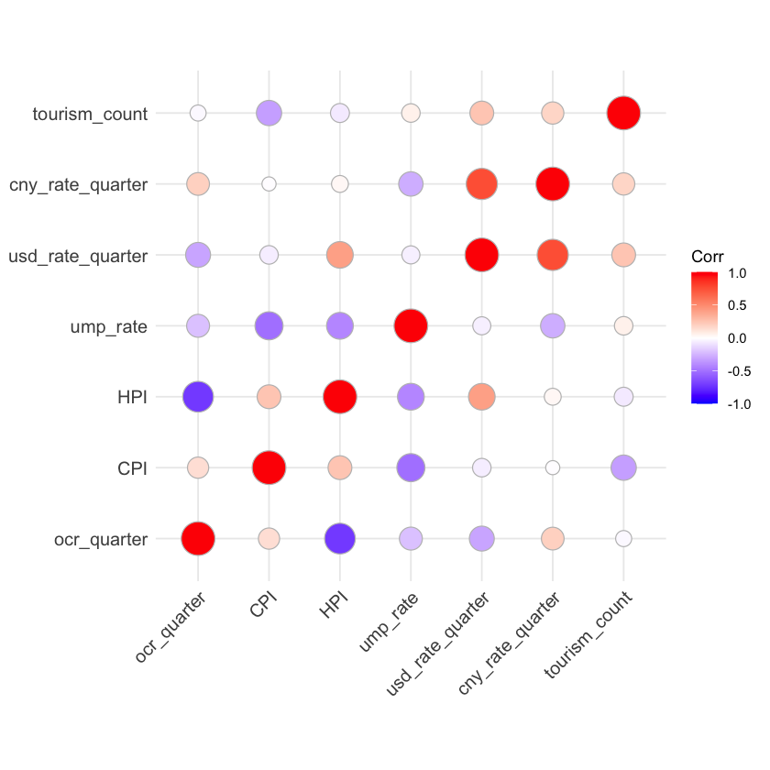

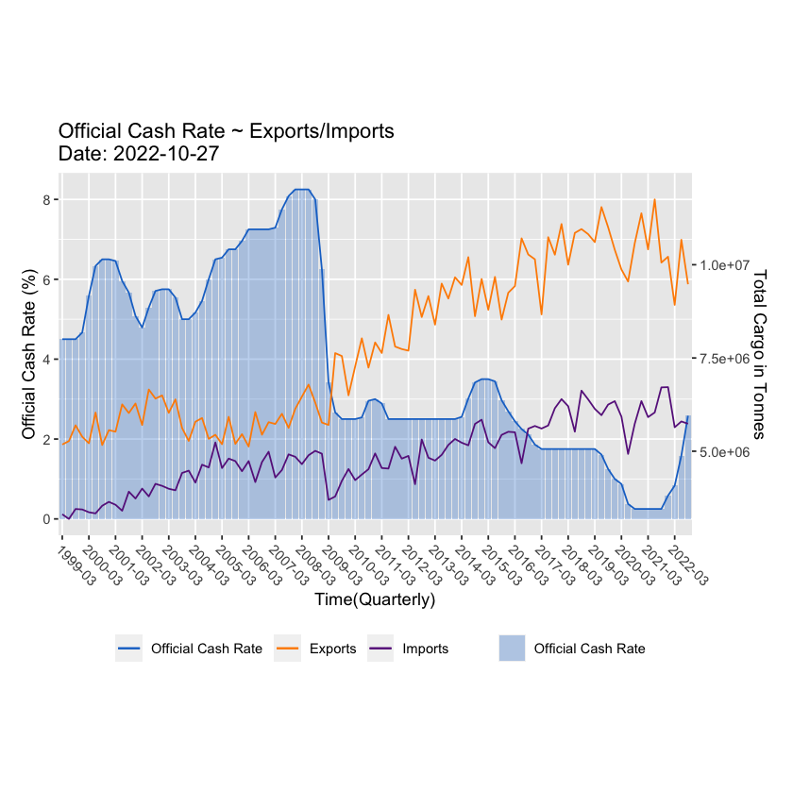

Lower interest rates increases net exports through the effects of lower interest rates on the foreign exchange rate, with cheaper New Zealand VS. Other currencies. It has made our diary products cheaper in the international market, thus make increase our export. Such monetary policy effects is clearly visible in the graph we have generated, since year 2009 onwards, the prolonged low OCR policy leads to years of increase of the export volume, the increase of the import volume could be the results of “Sign of the Free Trade Agreement between New Zealand and China”, which was signed in [2]year 2008 April 7th. The drastic increase of the trade volume as an impacts of such “Free Trade Agreement” is clearly visible on the chart.

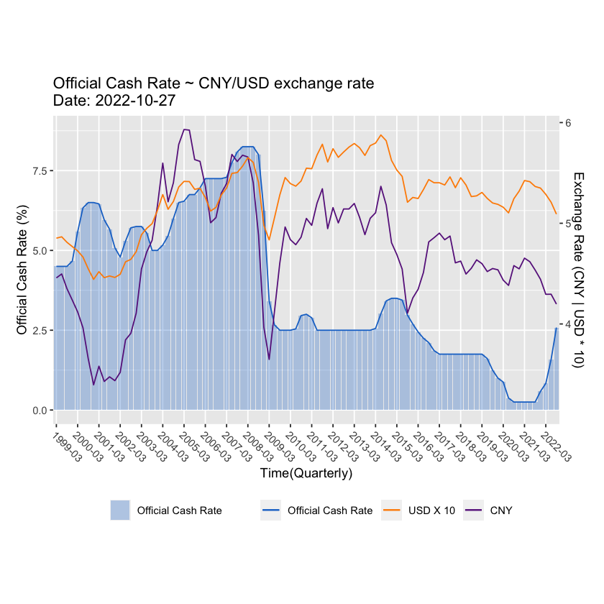

Another interesting phenomena can be observed in the above graph generated,China does not have a floating exchange rate that is determined by market forces, as is the case with most advanced economies. Instead it pegs its currency, the yuan (or renminbi), to the U.S. dollar. The yuan was pegged to the greenback at 8.28 to the dollar for more than a decade starting in 1994. That explains why the trends of the US dollar VS. NZ dollar exchange rates is almost mirrored by the CN yuan VS. NZ dollar exchange rate.

## Quality Control

(Data Wangling ---- Filtering …)

### D : What difficulties you have to overcome to wrangle the data sources into the target data model

We faced difficulties of finding keys between these entities, these historical data are not collected with the same frequencies. Some of them are collected on annual base, some of them are collected on monthly base and some of them are collected on quarterly basis. We need to wrangle these data to form unified keys for further construction of the relationship between these entities.

## Summary/Conclusion

The relationship key between these entities are timestamps (Year, Month, Quarter); Based on economical principles, as New Zealand Reserve Bank sets its interest rate up, business will have difficult of getting cheap loans for further development, it is anticipated that business development will be reduced, which leads to increase of unemployment. On the other hand, increase of Reserve Bank interest rate will attract oversea hot money for short term investment, therefore it is anticipated that exchange rate of New Zealand dollars VS. Other currency will go up. The high Reserve bank interest rate will lead to lower level of economic activities, hence in term of cargo freight statistics, general vehicle activities and tourism account, we are anticipating dropping in these activities. However, Reserve Bank raise interest rate usually to combat high inflation rate (CPI), therefore, we should be expecting dropping of the CPI.

When the economic activities are low and unemployment rate is high, the government is under pressure to unleash new monetary policies to stimulate economy. Hence government usually resolve to lower reserve bank interest rate. With high reserve bank interest rate, we should be able to observe weak New Zealand dollars VS over currency. Thus make export of our products cheaper, therefore attracts more oversea orders, subsequently we should be able to observe an increase of freight transportation activities, oversea passage flights. To stimulate general economic growth, government usually starts major infrastructural projects like major road works, etc. Hence it is also anticipated that general road construction activities are increasing.

In all, we can conclude that we have successfully created a data model that support in-depth analysis of New Zealand economy, especially revealing the relationship between government monetary policy VS. main economic activities.

## Appendix

**OCR** : The official cash rate (OCR) was introduced in New Zealand in March 1999. It is a conventional tool by international standards. Before we had the OCR, we used a variety of tools to control inflation, including influencing the supply of money and indicating desired monetary conditions to the financial markets.

**CPI**: The Consumer Price Index (CPI) is a critical indicator of pricing pressures in an economy and provides a gauge of inflation. Forex traders monitor the CPI, as it can lead to changes in monetary policy by the central bank that will either strengthen or weaken the currency against rivals in the markets.

**HPI** : A house price index (HPI) measures the price changes of residential housing as a percentage change from some specific start date (which has an HPI of 100). Methodologies commonly used to calculate an HPI are hedonic regression (HR), simple moving average (SMA), and repeat-sales regression (RSR).

## References (APA)

1. , <https://www.rbnz.govt.nz/monetary-policy/about-monetary-policy/the-official-cash-rate>
2. The effect of Regional Trade Agreements (RTAs) on Foreign Direct Investment in New Zealand: the case of the New Zealand–China Free Trade Agreement, <http://hdl.handle.net/10292/4612>